**PRACTICAL-5**

**AIM:**

An organization is having 3 braches at 3 different locations. The founder of organization wants to configure the WAN connection amongst all the branches for better communication, file sharing and resource sharing. Demonstrate the dynamic routing configuration using OSPF protocol for the given scenario using cisco packet tracer.

**THEORY:**

* OSPF stands for “OPEN SHORTEST PATH FIRST”
* OSPF is a routing protocol for IP networks
* OSPF was designed as an INTERIOR GATEWAY PROTOCOL (IGP), for use in an autonomous system such as a local area network (LAN).
* It implements Dijkstra's algorithm, also known as the shortest path first (SPF) algorithm
* Two routers speaking OSPF to each other exchange information about the routes they know about and the cost for them to get there.
* When many OSPF routers are part of the same network, information about all of the routes in a network are learned by all of the OSPF routers within that network—technically called an **area**.
* Each OSPF router passes along information about the routes and costs they’ve heard about to all of their adjacent OSPF routers, called **neighbors**.

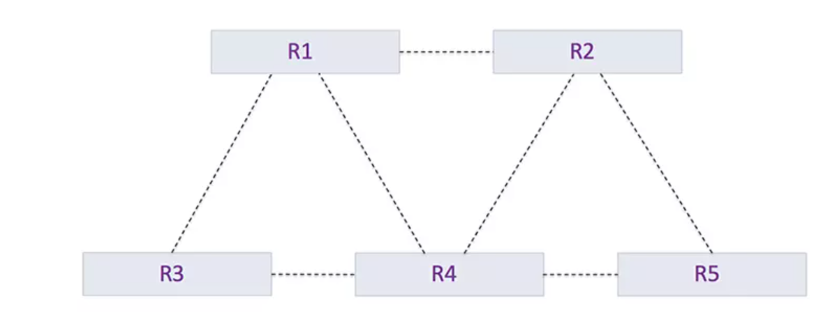

**PRACTICAL IMPLEMENTATION:**

* As there are 3 different branches at 3 different locations, so we will need 3 routers
* Also, we will connect the individual router with switches so, more PCs can be added into future.
* Currently, we will start with two PCs connected with

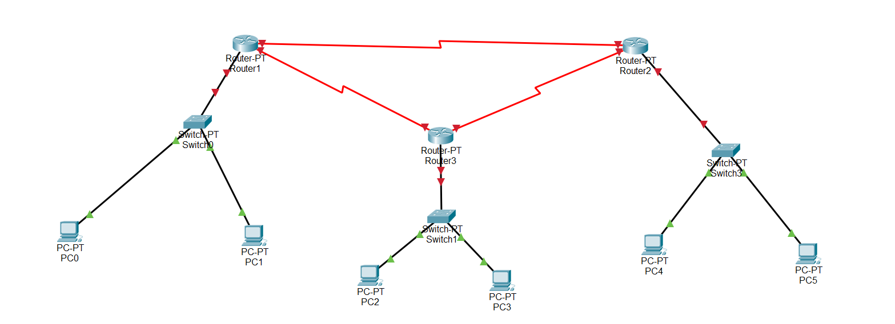

* Now, we will assign the IP address to each PC and also, we will define the network.

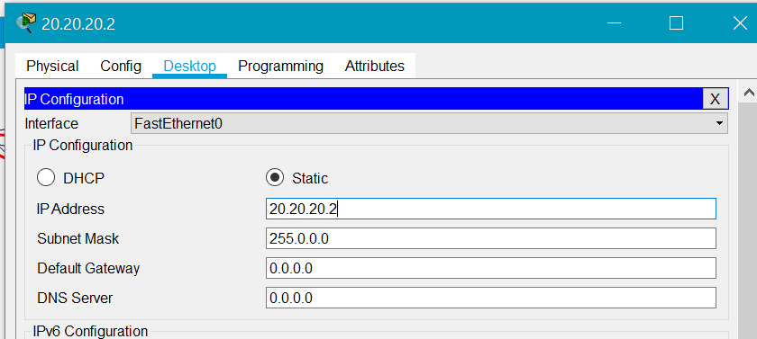

* We will also assign the default gateway to all.

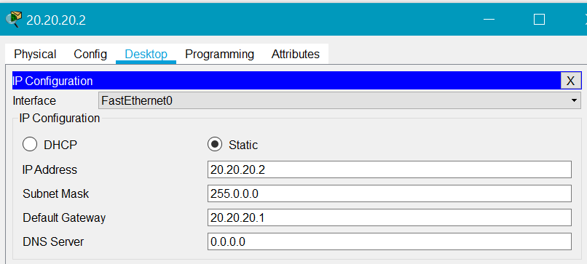

* Now, we will configure each and every router.

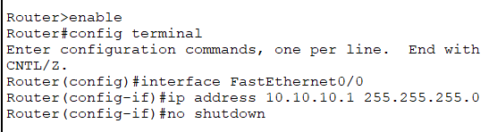

* We will perform the same steps with all the routers till the connections are established.
* Also, we can use config interface to configure the connection.

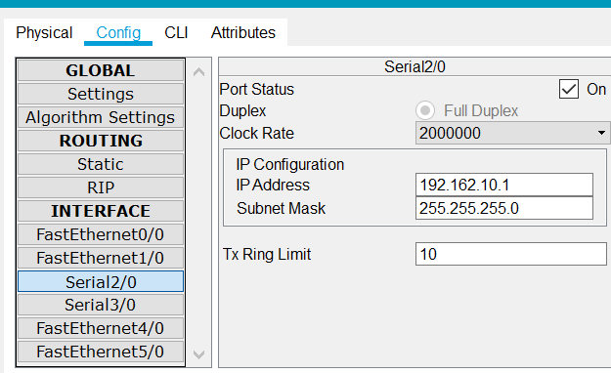

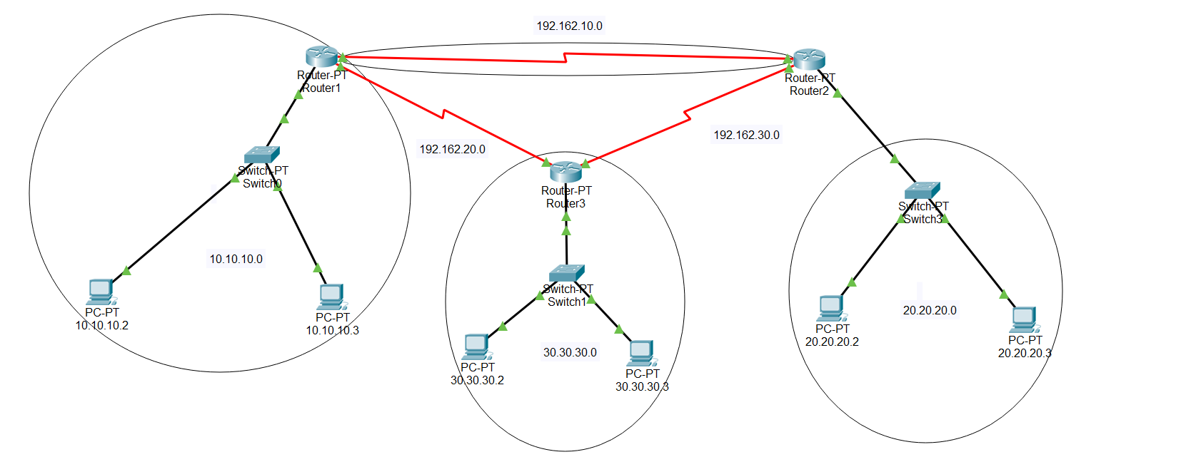

**CURRENT STATUS OF THE NETWORK AFTER ALL THE DEVICES ARE CONFIGURED.**

* Now, we will provide the routing information

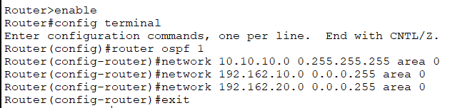

* Follow the above steps in all the routers.
* To check the routing table, exit from config mode and write “show ip route”.

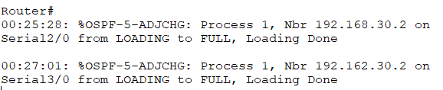

**Routers are exchanging the routing information.**

**TESTING THE WORKING OF NETWORK:**

1. **PDU TEST**

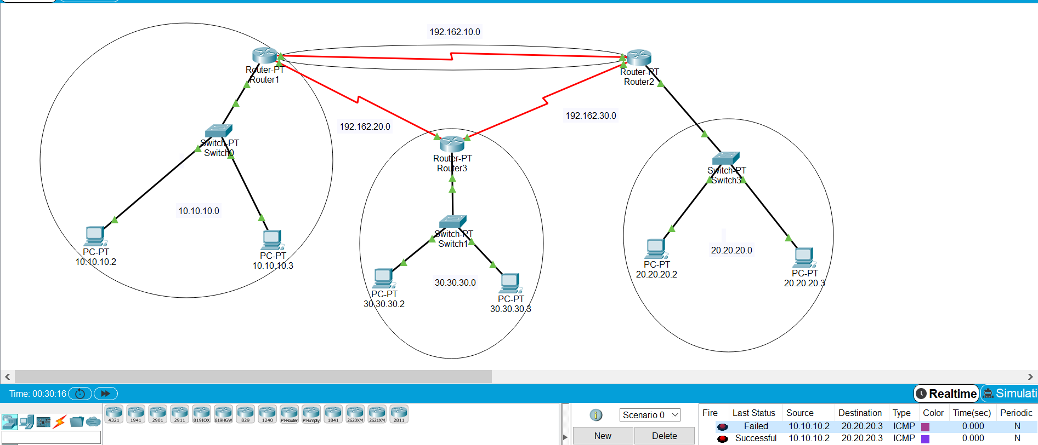

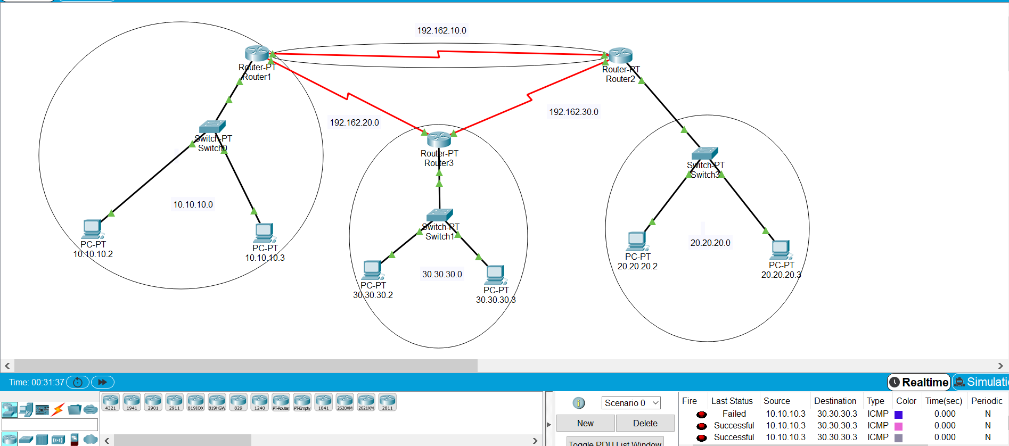

1. **PING TEST:**

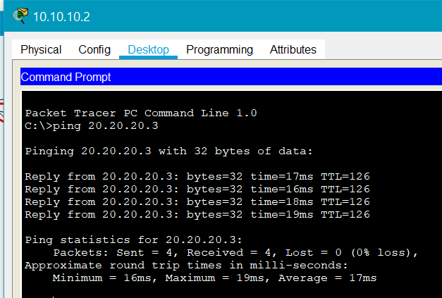

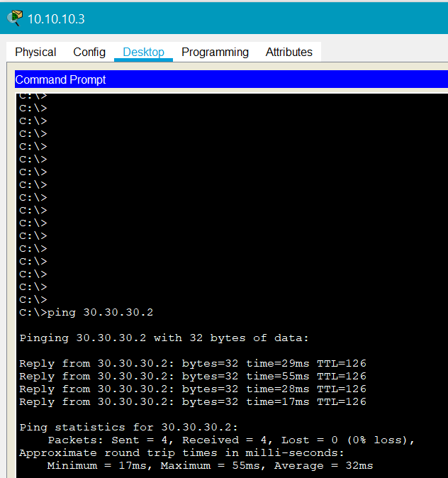

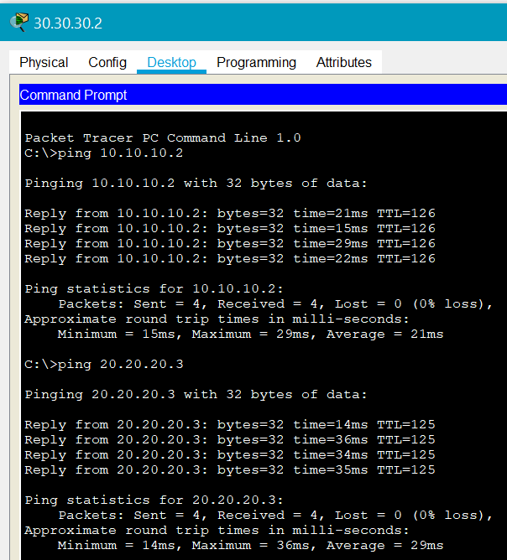

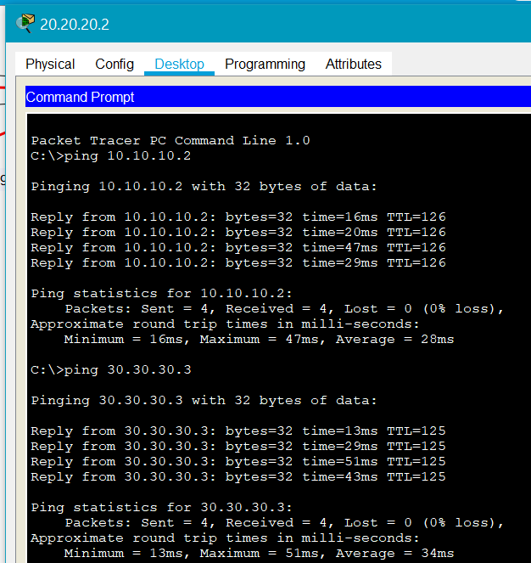

**CONCLUSION:**

By performing the above practical, we learned the concept of OSPF and how it works in the real world.

Also, we learned how to create a topology and configure OSPF to depict the real time working of OSPF.